Hannah Rutt

**Hannah Rutt**

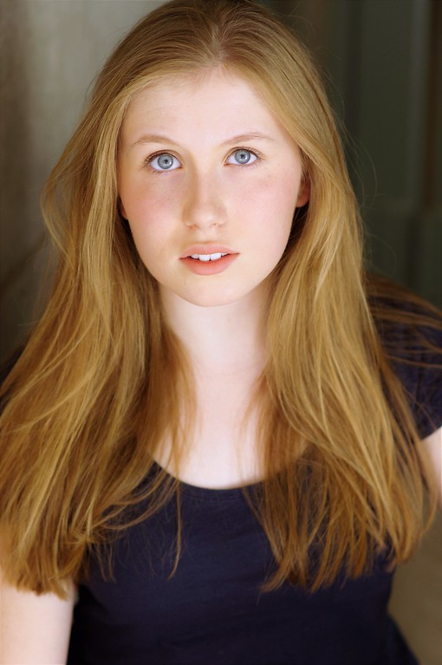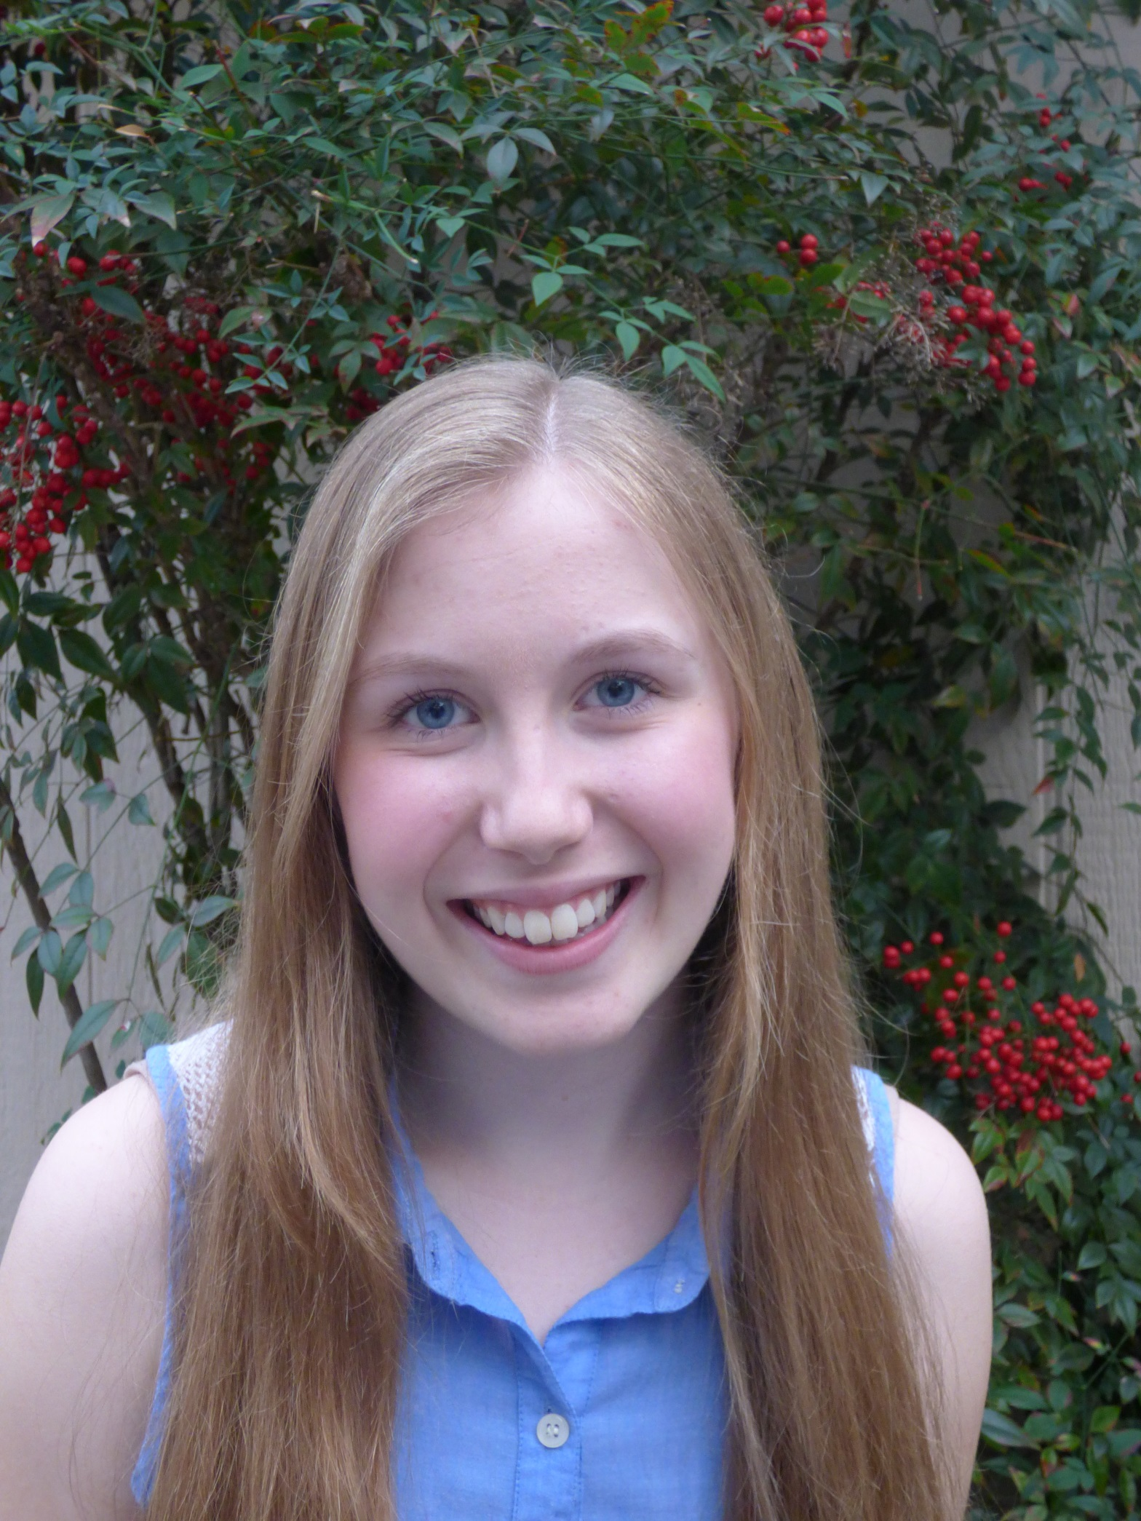

5’ 2’’

Blonde

120 lbs

Blue eyes

Mezzo-soprano

G3 – A5

**10503 Ames Lane Austin, Texas 78739**

**(408) 508-8503**

[**hannahrutt8@gmail.com**](mailto:hannahrutt8@gmail.com)

**Stage Experience**

**Production Role Company**

*The Crucible*  Betty Parris Austin Shakespeare

Staged Reading

*John Gabriel Borkman* Frida FoldalDifferent Stages

*A Midsummer Night’s Dream* Hermia Young Shakespeare

*The Impossible Mission (A Devised Piece)* Mooshkins Zachary Scott Theatre Performing Arts School

*Mary Poppins*  Mrs. Corry James Bowie High School

*Tarzan* Ensemble James Bowie High School

**Film & Voice Experience**

**Production Role Director**

*Love’s Labour’s Lost* Extra Jennifer Sturley

*Journey: Descent Underground (Video game)* Iris (Voice) Descendent Studios

**Training**

**Class Instructor Location**

Vocal Lessons Megan Richards-Wright Zachary Scott Theater Performing Arts School

Musical Theatre I-III Marco Bazan Bowie High School

Advanced Theatre I Kalyn Holloway Bowie High School

Theatre II-IV Betsy Cornwell Bowie High School

College Bound Conservatory Kate Shaw-Nappi Zachary Scott Theater Performing Arts School

Improvisation Master Class Michael Jastroch Zachary Scott Theater Performing Arts School

Auditioning for the Camera Master Class Adrianna Garza Zachary Scott Theater Performing Arts School

Beginner Ballet and Jazz Karly Powell Zachary Scott Theater Performing Arts School

**Skills**

**Dialects:** British, American **Aerial arts:** Basics of silks, lyra, hammock

**Misc.:** Chipmunk voice, Basic Piano, **Computer Skills:** Touch-typing

French Language,

Can say “supercalifragilisticexpialidocious” backwards