**Hannah Rutt**

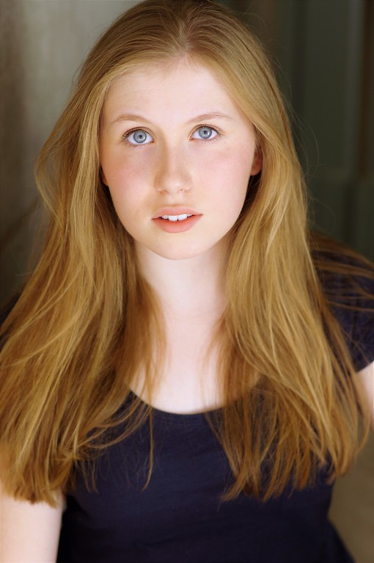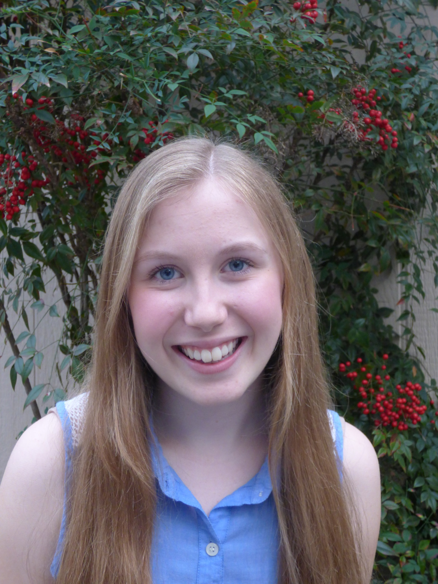

5’ 2’’

Blonde

135 lbs

Blue eyes

Mezzo-soprano

E3 – C6

**10503 Ames Lane Austin, Texas 78739**

**(408) 508-8503**

[**hannahrutt8@gmail.com**](mailto:hannahrutt8@gmail.com)

**Stage Experience**

**Production Role Company**

*Heathers* Stoner Chick Southwestern University

*Sideways Stories from Wayside School* Leslie Southwestern University

*The Crucible*  Betty Parris Austin Shakespeare

Staged Reading

*John Gabriel Borkman* Frida FoldalDifferent Stages

*A Midsummer Night’s Dream* Hermia Young Shakespeare

*The Impossible Mission (A Devised Piece)* Mooshkins Zachary Scott Theatre Performing Arts School

*Mary Poppins*  Mrs. Corry James Bowie High School

*Tarzan* Ensemble James Bowie High School

**Film & Voice Experience**

**Production Role Director**

*Love’s Labour’s Lost* Extra Jennifer Sturley

*Journey: Descent Underground (Video game)* Iris (Voice) Descendent Studios

**Training**

**Class Instructor Location**

Acting: Departures from Realism Joey Banks Southwestern University

Comedy Improv Workshop Ted Meredith Southwestern University

Musical Theatre Performance Workshop Joey Banks Southwestern University

Fundamentals of Acting CB Goodman Southwestern University

Clown Master Class Aitor Basauri CB Goodman Productions

Vocal Lessons Megan Richards-Wright Zachary Scott Theater Performing Arts School

Musical Theatre I-III Marco Bazan Bowie High School

Theatre I-IV Betsy Cornwell Bowie High School

College Bound Conservatory Kate Shaw-Nappi Zachary Scott Theater Performing Arts School

Beginner Ballet and Jazz Karly Powell Zachary Scott Theater Performing Arts School

**Skills**

**Dialects:** British, American **Aerial arts:** Basics of silks, lyra, hammock

**Misc.:** Chipmunk voice, Basic Piano, **Computer Skills:** Touch-typing

French Language,

Can say “supercalifragilisticexpialidocious” backwards

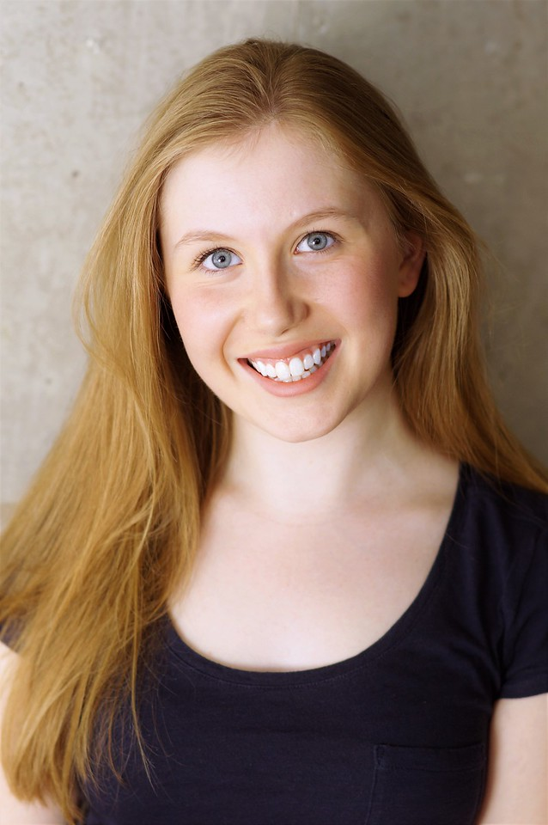

Hannah Rutt