Part One: Final Product

Personal Acting Manifesto Script

(*Lights up on a black box theatre classroom. A professor, CB Goodman, stands next to a chalkboard on wheels in the center of the classroom, with a piece of chalk in hand ready. The students should pick up the pace of raising their hands, some speaking almost simultaneously as the scene progresses, with many neglecting to raise their hands at all, just shouting out into the open.*

*The classroom space should be realistic, but there should be some indication of something strange and dream-like underneath the surface, perhaps demonstrated through a blurry layer of video or wobbly camera angles.*

CB *writes “Fundamentals of Acting” across the top of the chalkboard.*

*As each student suggestion is made,* CB *adds it to the board.*)

CB: So, class, what do we think?

DEMI: Projection, being able to be heard by the audience.

LOGAN: Communication. Like, collaboration with other actors.

LUIS: To cooperate?

MILLIE: Working with the whole crew to achieve the director’s vision?

(CB *uses her chalk to circle “collaboration”.*)

GRACIE: Focus.

LILLY: Commitment and dedication?

JESUS: Experimentation, observing and playing with your body and voice as your instrument.

EMMA: Warming up?

KYLE: Yeah.

CAMPBELL: Umm, memorization?

SAMUEL: Yeah… (*sighs under his breath, not realizing this was the answer* *that* CB *was looking for*).

CB: Yes, thank you, I had been waiting for someone to say that.

(HANNAH *enters, out of breath, a backpack on her shoulders, and a grocery bag filled with clothes, shoes, and a makeup bag across her right arm. With her left hand, she is also holding onto a water bottle with an unutilized carabiner clip.*)

HANNAH: (*trying to enter quietly but unable to contain her nervous energy*) I am so sorry I’m late…

(HANNAH *sits down next to* DEMI a*nd subtly tries to ask DEMI what she missed while simultaneously trying to grab a notebook to jot down the “Fundamentals of Acting”.The whole point of* HANNAH*’s character is that she gives herself entirely too many actions to perform at a time. This means that an actor performing as* HANNAH *will be interesting to watch; she will be performing multiple physical activities in addition to her inner action/objective that she desires from her scene partner.*)

CB: (*notices* HANNAH, *but does not depart from her class procedure. She writes “preparedness” and “on time” on the board*) Well, anything else?

HANNAH: Yes, an important fundamental could be how the process is just as important as the product. (*She looks to* DEMI *for support, but* DEMI *is looking straight ahead, almost blankly, at the chalkboard.*)

HANNAH: (*trying to elaborate*) Like, the chapter we read in Theatre for Beginners? “Rehearse”, I think?

HANNAH: Or we could say that the process is just as important as the product? Or that acting should be about experimentation, that it should be a fun development proc

(HANNAH *looks around. It’s as if no one has heard her. She tries again, waving her arm in the air this time.*)

HANNAH: (*whispering desperately*) Demi, this is making sense, right?

(HANNAH *breathes in sharply, knowing that her mistake, her tardiness, is being talked about in the open now. She starts to panic. Then, suddenly,* HANNAH *wakes up. She looks around her dorm room to the clutter of her bedside table— her tissue boxes, HobNob biscuits, glasses lying next to their case, and her loose sticky note lists. She pulls off her phone from her charger.*)

HANNAH: (*reading the time out loud*) 5pm. What?

*(She next opens up her computer, which she finally realizes is at just shy of falling off at the foot of her bed and begins reading the document she was most recently working on.*)

HANNAH: Personal Acting Manifesto by Hannah Rutt. 1. Characters should be relatable. Don’t be afraid to let your own personality be incorporated into your character work. 2. React and listen to your fellow collaborators. 3. Respect, learn, grow, develop. It helps create the most positive working environment possible. 4. Having multiple physical activities while seeking an objective action will make a performance more engaging for the audience. 5. Actors should put their characters in the highest stakes possible so that their actions are meaningful. 6. Look to other disciplines to inform theatrical work, borrow strategies from other fields to create multidisciplinary work. 7. Acting is about experimentation and discovery! 8. Be aware of your own habits and idiosyncrasies and make a conscious choice whether or not to carry them through to your characters. 9. Theatre should be fun for the audience and for the performers, designers, and crew!!! 10. Most importantly, the PROCESS is just as important as the PRODUCT. Finally, a note: Cite class commentary. Attribute class comments to each classmate: Projection, being able to be heard by the audience (Demi), Communication, collaboration, and cooperation (Logan, Luis, and Millie), Focus (Gracie), Commitment and dedication (Lilly), Experimentation, Observing and playing with your body and voice as your instrument (Jesus), Warming up (Emma), and, last but not least, Memorization skills (Campbell).

(HANNAH *jumps out of bed, still in her rumpled, drab Theatre Set Lab clothes (which consists of an old, yellow Yosemite t-shirt and grey, too-tight leggings) and jumps around the room, bouncing and excited, getting her bag ready to leave for the library.*)

HANNAH: I did it, I actually finished!

(HANNAH *snatches her phone off of her bed, still unmade, and opens up her messages. Close up on* HANNAH *as she is seen texting a “Mum and Dad” chat. Message reads “Sorry I got quiet for a minute there. I’m done, off to the library to print.” Final shot consists of a satisfied smile fading out of view the door shuts behind* HANNAH.)

END OF SCENE.

Part Two: Looking Back at the Process

Section A: Written Representation in Personal Acting Manifesto Outline

Color coding system: Ideas borrowed from class, Ideas borrowed from sources, and Ideas that I consider “original”, or “unique” to me.

**Section 1: Addresses Beliefs, Goals, and Wisdom**

Beliefs (these are sort of a combined in class and already personally held)

1. I believe in connecting the body and mind, taking care of the instrument and being aware of all the unique ways in which parts of the body can move and interact with one another.
2. I want to have awareness of habits and ones that I would like to edit so as to not interfere with the creation of a character. I believe that one should not be afraid to start playing as yourself, however, because characters have to be relatable. Instead of judgment, play the character as a fully fleshed person that believes that what they say and do matters and has consequences.
3. I know to be true that the PROCESS is just as important as the PRODUCT. This is why I will show the paper and the Google Slides before presenting my final SCRIPT.
4. I am inspired by Acting Theory books such as An Actor Prepares by Konstantin Stanislavski and Sanford Meisner on Acting, The Actor’s Art and Craft: William Esper Teaches the Meisner Technique, both of which feature an instructor having a dialogue with his class in order to teach his theory.
5. I think that stories are always inherently influenced by biases and that the same story or at least the same story structure gets told over and over. I do not think there should be pressure to create something entirely original.

Concepts from this class that I most identified with. Beliefs from class.

1. “Blue doesn’t show up on blue”, or establishing reality before getting into the crux and strangeness of an improv scene.
2. REACTIVITY AND LISTENING with scene partners. Not pre-preparing emotion.
3. Exaggerate something and then dial it back down for realism. If you never go big, then you haven’t been vulnerable enough to create something that might be really meaningful.
4. Observation is key. Empathy in collaboration is essential to maintaining group positivity, ensemble energy in the amalgamation of efforts that is theatre. If I disagree with my director, then I need to let any and all resentment go as negative vibes will not serve to advance the production. If I am struggling to produce the desired effect of my director, then I can use Practical Aesthetics to find a diverse array of actions and tools to explore the relationships in and the progressions of the scene in a different way.
5. Giving yourself multiple things to play with at a time. Have your set and your environment as specific as possible so that you can be, say, washing the dishes or reading a menu at the same time as speaking to your scene partner. It provides greater opportunities in terms of body language and how to pursue your actions through the way in which you move your set and prop pieces and the way in which you move through your environment (such as Viewpoints topography). Plus, humans are rarely ever just doing one thing, rarely ever just talking and nothing else so makes everything generally more relatable.
6. Putting yourself “in the shit” is very important!!! An audience will always be more interested to watch a higher stakes situation, and it also makes your work as an actor more fun and compelling!

Beliefs from Manifesto Sources

1. “Begin anywhere. John Cage tells us that not knowing where to begin is a common form of paralysis. His advice: begin anywhere.” -Bruce Maus
2. “The Girls used wit and irony to point a critical finger at double standards prevalent in the art world and elsewhere.” -Guerrilla Girls
3. “My favorite artwork is the next one I make.” -Red Alan. Can anything be art? Who decides whether art is good or bad? Does democracy have bad taste?
4. “We are cunning, and our fingers are malleable.” -Dada Manifesto. Relate this to the theatre being equal parts deception/falsehood and honesty/truthfulness?
5. “Worrying solves nothing. Everybody who is honest is interesting.” -Sagmeister.
6. “From this I gather that other’s freedom to interpret your work is just as vital as you sharing your meaning and your intent.” -Good Design. Relate back to our “critique structure” that we learned in class, critiques that are based off of observation rather than “good” or “bad” so that the artist herself can evaluate if she has achieved in portraying the themes and messages that she was trying to put forth.
7. “We are also aware that art is not just political. It is many other things besides… for art to

be effective it must not only know how to speak, but more importantly, it must know

what it wants to say.” -Bogside.

1. “No work without an aggressive character can be a masterpiece.” As much as I don’t

really believe in actively trying to put certain “masterpieces” up on pedestals, I feel intrigued by the emphasis on dynamic, unpredictable characters being more entertaining and, thus, necessary for the audience.” -F. T. Marinetti. Also, the narrative style of this manifesto (in addition to the aforementioned acting theory books) greatly inspired my decision to write a screen-play style manifesto.

1. “Thus, any fine artist who claims to be fully aware of his/her process and the cultural relevancy of their work is either being dishonest with their audience, or speaking out of professional naivety.” (<https://hyperallergic.com/67670/the-anti-artist-statement-statement/>)

**Section 2: Challenge Assumptions**

1. To me, to challenge assumptions means to value process just as much as product. It means to go “outside of the box” in recognizing that an amalgamation of diverse elements and ideas have to be present before a truly cohesive piece of art comes to be presented. I should elaborate that by “cohesive”, I do not mean that to suggest that a piece of theatre needs to have a linear plotline. Rather, the piece of theatre will be unified in its purpose (the meaning it would like to convey to the audience or the questions it would like to inspire its audience to ask) and its themes (topics linked to the human experience that the piece will explore).
2. “I write this manifesto to show that people can perform contrary actions together while taking one fresh gulp of air.” -Dada Manifesto

**Section 3: Foster Personal Commitments**

1. In order to practically achieve what my goals and uphold what I believe in, I will use journaling as a tool to understand developments and challenges. In class, I kept notes of my observations and CB’s directorial notes for each of the groups presenting scenes.
2. I will create goals both inside and outside of the context of a production. Working on a production is not the only type of training available to the actor. Rather, it is critical to take vocal and movement classes to improve and grow in different facets of one’s discipline.

**Section 4: Growth and Change**

1. As much as I have indicated that intentionally not emotionally pre-planning is important

to me, I have read before about the practice of Rasa boxes, and I believe that this could be very instrumental in my further growth and exploration of how to access emotion and use it to my advantage in several different ways: Firstly, it could help me represent emotion more authentically onstage. Secondly, it may allow for me to sift through all emotions in a focused way that allows me to start in an emotional neutral for my character, rather than trying to artificially project something onto my character.

1. “The Sanskrit word “rasa” can be translated as “juice, taste, flavor, essence.” The underlying concept is that rasa suffuses and inhabits our feelings. Rasa is a process rather than a thing. Rasas are the primary flavors such as salty, sour, sweet, pungent, astringent, and bitter. Rasas are distinct “flavors” of energy and emotion one feels during an artistic performance or in an everyday life situation” (http://rasaboxes.org/).

**Section 5: How will my ideas shape the world?**

1. I want to encourage others to be multidisciplinary. In Intro to Play Analysis, I read an article about “Diametrics”, or how the inclusion of mathematics and advanced technology is causing the field of theatre to evolve and develop. I want to encourage collaboration and the pursuit of looking at a concept through the perspective of someone different from oneself.
2. In tandem with my response to why I am so drawn to theatre, I want to emphasize to my audience how important it is to love and understand other human beings, and especially ones that they consider to be different from oneself. I think observing and connecting with characters opens up someone to new ways of thinking about the people that they interact within their own personal, day-to-day lives.

**Section 6: “Why am I Here?”, Purpose Question**

1. I am here because I gain insight into the human experience as a whole. Theatre can bring

up histories both mainstream and silenced, but they all give me a fresh perspective through the lens and viewpoints of others.

1. With all the expansions of technology and the increasing polarization of individuals both politically and socially in society, it is important to have the theatre to experience something visceral. An important part of theatre is to experiment in form and to make others feel uncomfortable or to have questions. The point of theatre is not to agree or disagree, to like or dislike. The point is to generate a conversation within oneself and around one’s community about why it might have been that a particular piece of theatre made them feel a certain way.
2. I am here because it is fun, and it is rewarding! It is escapist in a sense; it is working your very hardest towards something, and then being able to let it go feeling proud and knowing that you have put that work out there because it matters to you, and it might even contribute to someone else’s life or change their minds about something. The theatre is a key outlet for me to tap in my self-identity, what allowed me to feel comfortable with difference and not pressured to assimilate. As someone that always sounded different from everyone else in the room, theatre allowed me to see how personal idiosyncrasies can fuel conversation and meaningful human interaction more than trying to be the same as everyone else in my surrounding community. However, it also helped me to be unafraid to define myself by other things than being an immigrant, by being able to identify as sociable, bubbly, energetic, optimistic, and empathetic. In summary, I connect my confidence and understanding of myself and my personality directly with my participation in theatre.

Section B: Visual Representation in Google Slides

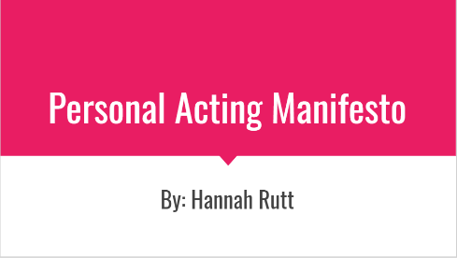

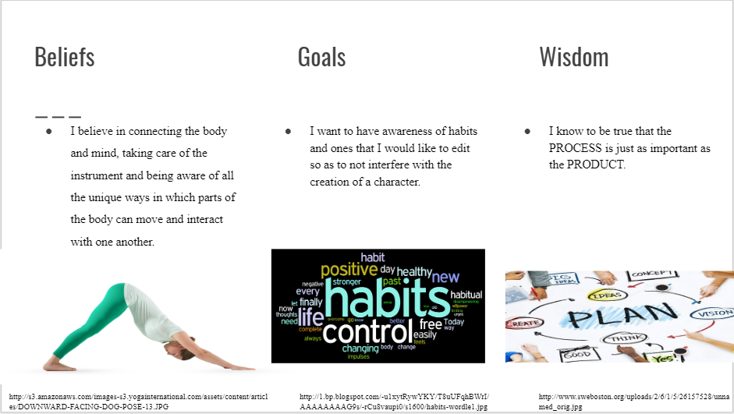

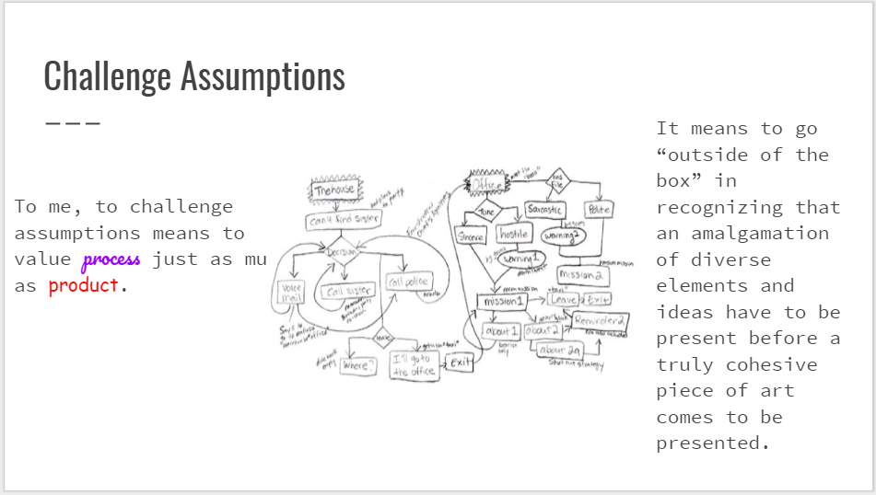

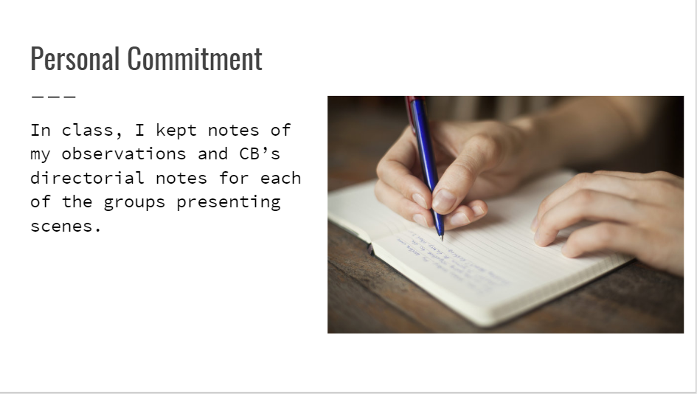

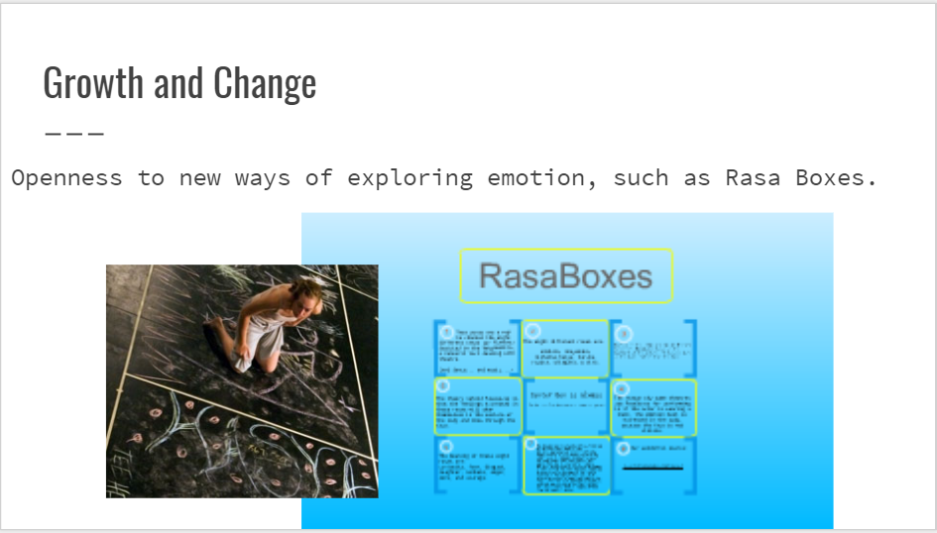



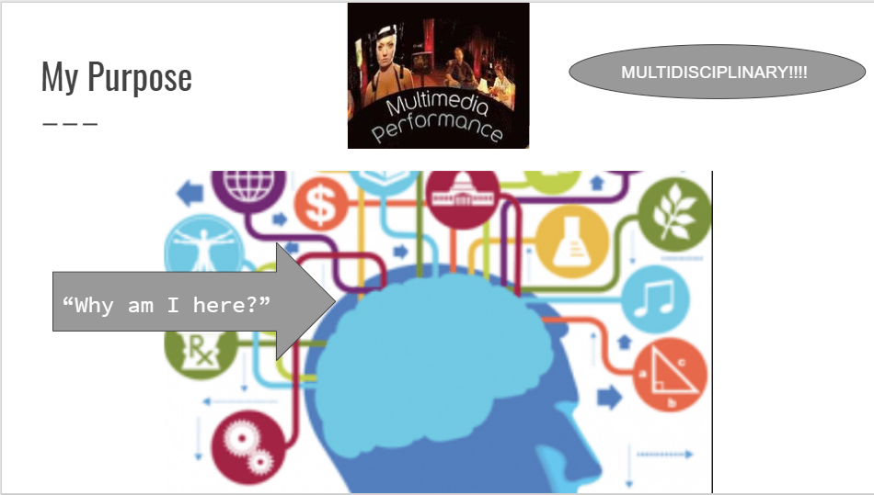

Part Three: Bibliography

*Moodle Provided Sources*

Anonymous, Guerrilla Girls. “Advantages of Being a Woman Artist.” Part of a series of *Guerrilla Girls Talk Back* posters, 1984-1992.

Brody, Neville. “ADF Manifesto.” A Manifesto for the Anti-Design Festival, London 2010.

Gropius, Walter. “Manifesto of the Staatliches Bauhaus Walter Gropius.” April 1919.

Kelly, Tom, William Kelly, and Kevin Hasson. “The Bogside Artists’ Manifesto.” 1993.

Marinetti, F. T. “The Founding and Manifesto of Futurism.” Translated by R. W. Flint. Thames and Hudson Ltd. London, 1973.

Mau, Bruce. “Incomplete Manifesto for Growth.” 2010—2014.

Perry, Grayson. “Red Alan Manifesto.” A Manifesto for “Reith Lectures” series, 2012.

Rams, Dieter. “Ten Principles for Good Design.” 1960-1963.

Sagmeister, Stefan. “Manifesto.” 2010-2014.

Tzara, Tristan. “Dada Manifesto.” 23rd March 1918.

*Supplementary Research*

Abrams, Loney. “Don't Quote Deleuze": How to Write a Good Artist Statement.” Posted March 15th, 2017. <<https://www.artspace.com/magazine/interviews_features/art-bytes/dont-say-deleuze-how-to-write-a-good-artist-statement-54662>>

Esper, William and Damon DiMarco. *The Actor’s Art and Craft: William Esper Teaches the Meisner Technique.* New York: Anchor Books, a division of Random House Inc., 2008.

Meisner, Sanford and Dennis Longwell. *Sanford Meisner on Acting*. New York: Random House Inc., 1987.

Morrison, Jasper. “Manifesto.” Accessed December 7th, 2018. <<https://www.readingdesign.org/manifestos-jasper-morrison>>

Oldenburg, Claes. “I Am for an Art.” Posted February 3rd, 2011. <<https://artiststatements.wordpress.com/2011/02/03/claes-oldenburg-i-am-for-an-art/>

Jaffe, Iris. “The Anti-artist-statement Statement.” Posted March 29th, 2013.

<<https://hyperallergic.com/67670/the-anti-artist-statement-statement/>>

Honor Statement Page for Personal Acting Manifesto

I have acted with honesty and integrity in producing this work and am unaware of anyone who has not.

-Hannah Rutt